https://www.newsweek.com/rep-annie-kuster-says-war-drugs-hasnt-translated-success-combating-opioid-crisis-1587515

Rep. Annie Kuster Says 'War on Drugs' Hasn't Translated to Success in Combating Opioid Crisis
By Lauren Giella On 4/29/21 at 1:18 PM EDT

ASP Explores: The Opioid Epidemic w/ Rep. Annie Kuster (D-NH) And Rep. Bob Latta (R-OH)

Before the COVID-19 pandemic, the United States was fighting another public health crisis. Opioid addiction has been ravaging the country for years. Combating the opioid crisis has been a bipartisan effort for years. In this episode of ASP Explores, Representatives Democrat Annie Kuster New Hampshire and Republican Bob Latta of Ohio discuss the causes of this epidemic and the actions needed to end it. Opioids include both prescription pain medications and illegal drugs like heroin whose misuse can lead to addiction or death. According to the National Institution on Drug Abuse, in 2019, around 10 percent of people using opioids for chronic pain developed an opioid use disorder.

Both Latta and Kuster agree that the best solution for this epidemic is widely available and effective treatment for addiction. Kuster said that the "War On Drugs" approach of using criminal justice "has not been successful" and that recovery should be the priority. "People don't have access to treatment during incarceration," she said. "This is a public health crisis. In every jail or prison, there is no insurance coverage to pay for mental health or substance-use treatment. People could use that time to recover and come out into society and be more productive citizens." Latta is determined to make change through legislation. He recalls the HR6 package of over 50 bipartisan bills focused on prevention, treatment and recovery initiative for opioid use and addiction was signed into law in 2018.

More recently, Latta's Debar Act passed in the House in April. The Debarment Enforcement of Bad Actors Registrants Act authorizes the U.S. Drug Enforcement Administration to bar an entity from registering to manufacture, distribute or dispense controlled substances under certain circumstances. "We want to get to the root of the problem.… it's important that we do have treatment out there for people that really want to make a difference and get off this stuff," Latta said.

One of the factors that led to this crisis, Latta said, is overprescription. At a hearing for HR6 in 2018, Latta asked everyone on a panel why this crisis seems to only be prevalent in the United States. "They all said it's very simple: We overprescribe," Latta said. "That's why we need to focus on pain management and other types of prescriptions that aren't opioids." Kuster said for a while, doctors were incentivized to prescribe opioids to patients. "Medicare has quality indicators [to determine] if someone is a good physician or surgeon," she said. "One was whether or not their patient experienced pain long after surgery. So instead of a handful of pills to get through a couple of days of pain, they would give 30, or 60 or 90." When those legal prescriptions run out, she added, people turn to illegal measures, like "heroin on the streets."

The Centers for Disease Control and Prevention found that there were 72,000 opioid overdose deaths in 2019, a 5 percent increase from the year before. During the pandemic, Latta said that number rose to 88,000 deaths in 2020. "[The opioid crisis] is an ongoing fight we are in," he said. "It's in your hometown, it's on your street and it could be in your own family. People are shocked when they find out someone has some type of addiction."

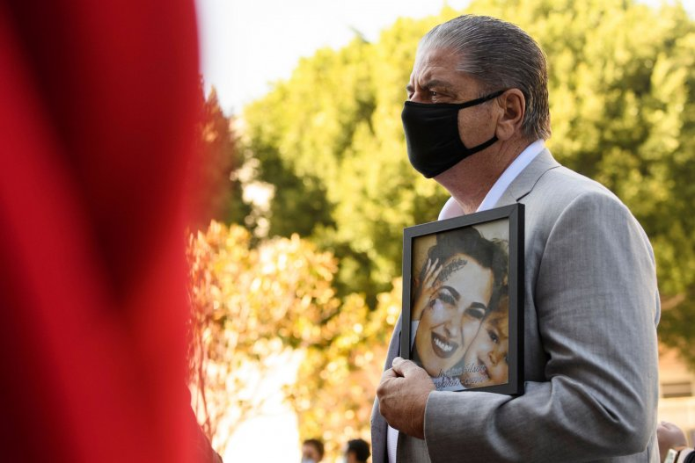
Steve Filson carries a photo of his daughter Jessica Filson, who died in January 2020 of opioids, during a news conference on February 24 in Los Angeles. Combating the opioid crisis has been a bipartisan effort for years. Representatives Annie Kuster New Hampshire and Bob Latta of Ohio discuss the causes of this epidemic and the actions needed to end it. PATRICK T. FALLON/AFP via Getty Images)

Read more
- Fentanyl Seizures at Southern U.S. Border Have Increased 233% in One Year
- The Big Pharma CEO Who's Helping to Put an End to COVID-19
- Marijuana Legalization Isn't Delivering What Supporters Promised
- U.S. Sets Record for Overdose Deaths During Pandemic

